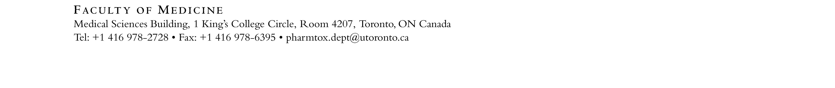

Lecture Based Teaching Assistantship Application Form 2019-2020

Please return the completed form along with a cover letter and a copy of your résumé to undergrad.pharmtox@utoronto.ca.

Please note that students can hold Teaching Assistantship in 1 lecture-based course and/or 1 laboratory-based course.
A separate application is required for laboratory-based courses and invigilation.

Applicant Name: |  | Email Address:
Home Phone: |  | Work Phone:
University Address:

Department: |  | Program:  Undergrad MSc PhD PDF
Year in Program (as of September 2019): |  | Current Supervisor:
Position(s) applied for (please rank in order of preference):

1. |  |  | 4.
2. |  |  | 5.
3.

What is your background experience in Pharmacology and/or Toxicology? Please include relevant coursework.

Which of the following areas do you have experience with? Please check all that apply:

Behavioural Pharmacology | Biochemical/Molecular Pharmacology |  |  | Cardiovascular Pharmacology
Clinical Pharmacology | Co-op / PEY / Professionalism |  |  | Drug Metabolism
Endocrine Pharmacology | Immunopharmacology |  |  | Pharmacokinetics
Receptor Pharmacology | Signal Transduction |  |  | Toxicology
Other (please state):

The University of Toronto is strongly committed to diversity within its community and especially welcomes applications from visible minority group members, women, Aboriginal persons, persons with disabilities, members of sexual minority groups, and others who may contribute to the further diversification of ideas.

